
Smart Classroom Energy Saver

Internet of Things Project
Project Proposal

Paraic Gavin
BEng(H) in Software & Electronic Engineering
Atlantic Technical University
2025/2026

Project Description

Did you know that schools and universities waste up to 30% of their total electricity each year due to lights, fans, and air conditioners being left on in empty classrooms? This unnecessary energy consumption not only increases operational costs but also contributes significantly to carbon emissions and as a result harms the environment. As educational institutions strive to become more sustainable, energy efficiency has become a priority. I believe that one effective approach to addressing this issue is through the implementation of my project: The Smart Classroom Energy Saver.
The Smart Classroom Energy Saver is an IoT-based system designed to automatically manage classroom electrical appliances based on the occupancy of the room. Using an ESP32 microcontroller, the system detects human presence through PIR motion sensors and controls electrical devices such as lights and fans through relay modules. When a person enters the classroom, the system automatically switches on the devices, and when the room is vacant for a specific period, it powers them off. This automation ensures optimal energy usage without requiring manual intervention.
To implement this system, I will use the Arduino IDE to program the ESP32 using C and C++. The ESP32 will process real-time data from multiple PIR sensors placed strategically within the classroom. Each relay connected to the ESP32 will control a corresponding electrical device. For remote monitoring, the ESP32 will transmit data via Wi-Fi, where people can view the real-time status of classroom devices and total energy usage. The system’s simple design allows it to be scaled easily to multiple classrooms or buildings.
An optional feature of the project includes integrating a light intensity sensor (LDR) to automatically dim or switch off lights when sufficient daylight is available.
The primary objective of this project is to reduce energy waste and costs in educational environments by taking advantage of IoT automation. By implementing this system, institutions can significantly lower their electricity bills and carbon footprint, while also promoting sustainable practices among students and staff. The Smart Classroom Energy Saver represents a practical and impactful solution that aligns with Sustainable Development Goal (SDG) 7 — Affordable and Clean Energy and SDG 13 — Climate Action, advancing the global mission toward smarter, greener campuses.

Architecture Diagram

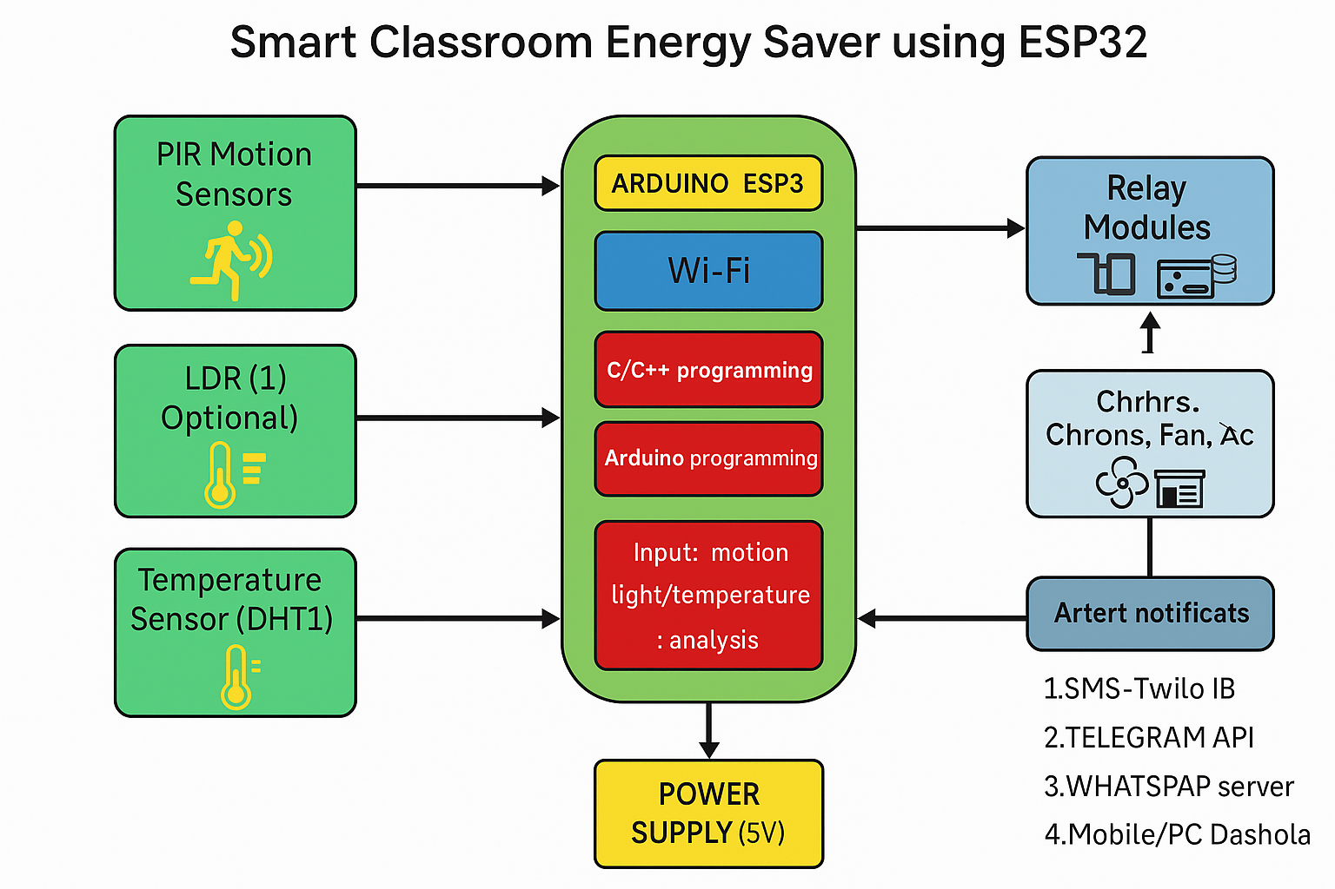

Feasibility
Completing the Smart Classroom Energy Saver project and ensuring that the system performs reliably in real classroom conditions may require additional time for testing. The setup involves multiple sensors, relays, and Wi-Fi communication, which could lead to longer integration and debugging phases.
There is a possibility that the wiring and sensor placements may make the installation process slightly complex, especially in larger classrooms with multiple devices. This could require additional effort to manage power distribution and conceal parts for safety and aesthetic reasons.
False detections by the PIR motion sensors represent another potential challenge. For instance, the sensors might trigger when there is minimal movement, such as from air circulation or reflections, leading to lights or fans switching on unnecessarily. Similarly, if sensors fail to detect occupants correctly, devices might turn off prematurely, causing inconvenience. These issues can be minimized through sensor sensitivity adjustments and proper placement.
Finally, the system’s dependence on stable Wi-Fi connectivity for cloud monitoring introduces a risk of data delays or temporary loss of communication. In case of network outages, the ESP32’s local automation logic ensures that lights and fans continue to operate autonomously, even without an internet connection.

Meeting United Nations’ Sustainability Development Goals UN SDGs

Goal 7: Affordable and Clean Energy
7.3: The Smart Classroom Energy Saver (SCES) contributes directly to improving energy efficiency by reducing unnecessary power consumption in educational institutions. By automatically controlling lights, fans, and air conditioners based on occupancy and natural lighting levels, the system ensures that electricity is used only when needed. This promotes responsible and sustainable energy use, aligning with the global effort to achieve affordable and clean energy for all.
Goal 12: Responsible Consumption and Production
12.2: The project encourages responsible use of electrical resources within schools and universities. Through automation and monitoring, it minimizes wasteful energy practices and helps institutions better manage their electricity usage.
Goal 13: Climate Action
13.3: The (SCES) significantly reduces energy waste and carbon emissions. It raises awareness among young people about the importance of environmental responsibility.
Schedule
10/2025 - Research
Gather information on how to build and connect all the components to the ESP32. Order the components needed to build the device.
11/2025- Build the circuit.
Start by connecting the motion sensors and test the circuit. If working, add more sensors until the circuit is complete.
12/2025- Code
Program the code that sends commands to the device in the way it is supposed to function.
01/2026 – Debugging and Test
Run tests to see if the device works as programmed. Tweak minor issues.

References
[1] Espressif Systems, “ESP32-WROOM-32: Technical Datasheet,” 2024. [Online]. Available: https://www.espressif.com/en/products/socs/esp32
[2] Arduino, “Using PIR Motion Sensors with ESP32,” 2024. [Online]. Available: https://www.arduino.cc
[3] Blynk Inc., “Blynk IoT Platform for ESP32 Projects,” 2023. [Online]. Available: https://blynk.io
[4] United Nations, “Sustainable Development Goals (SDGs),” UN Department of Economic and Social Affairs, 2024. [Online]. Available: https://sdgs.un.org/goals
[5] ThingSpeak, “IoT Analytics Platform for ESP32 and Arduino,” MathWorks, 2024. [Online]. Available: https://thingspeak.com
[6] PIR Motion Sensor, How PIRs Work | PIR Motion Sensor | Adafruit Learning System
[7] Relay Modules, Exploring Relay Modules: Definition, Functions and Principles – Schneider Electric

